

Lab Report 10

Muhammad Rafay
20P0018
Computer Network
Sec A

HTTP analysis using Wireshark

- 1. Is your browser running HTTP version 1.0, 1.1, or 2?

Ans: Open the Wireshark
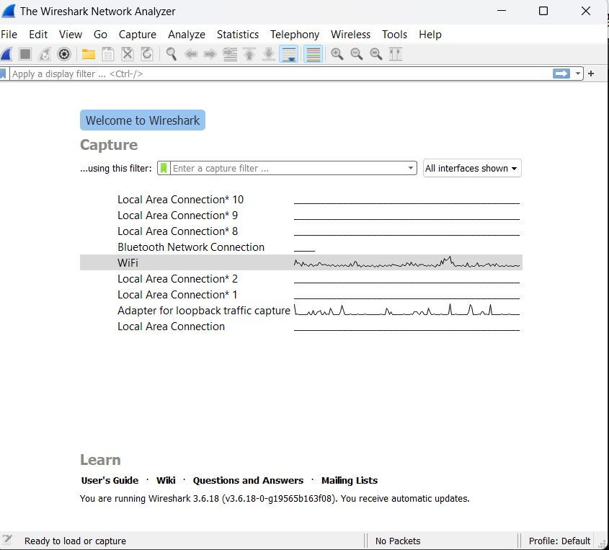

Start
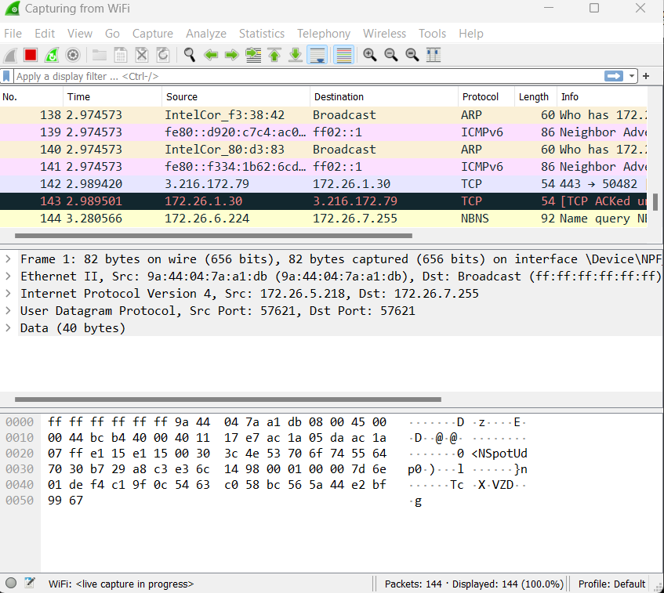

Select the network:

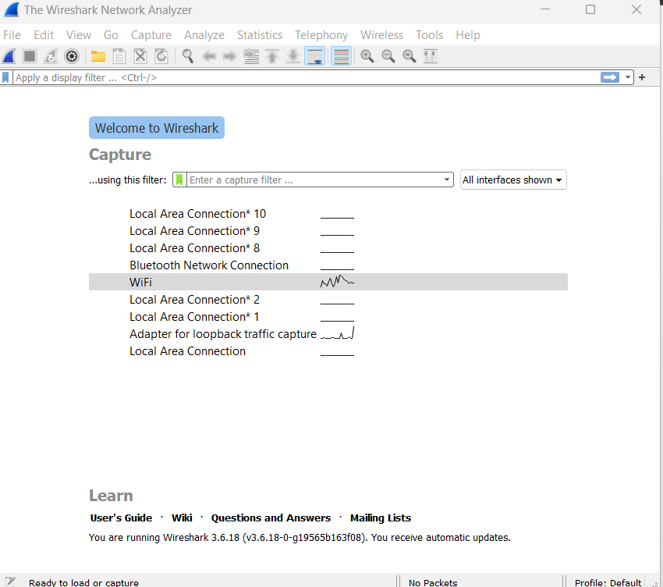

Select the wi-fi and double click it.
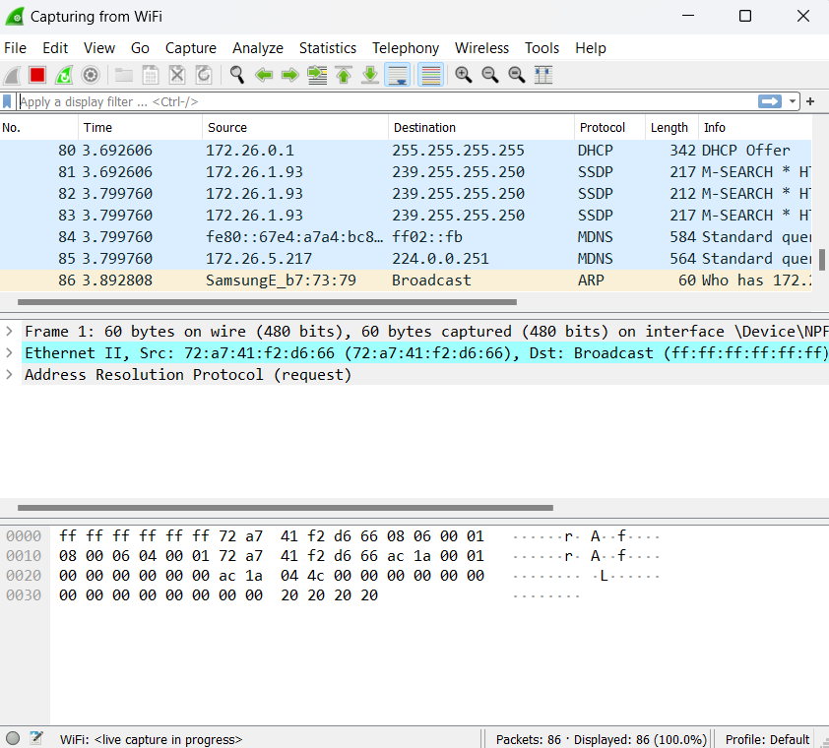

Search the http sever
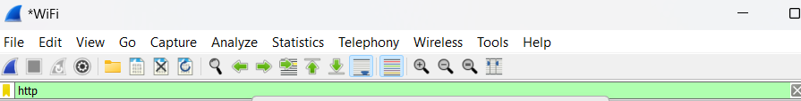

Request downloading the file

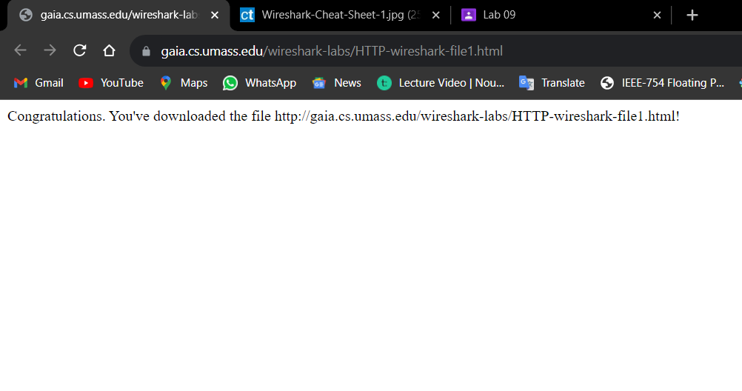

After run this HTTP in web sever and open the wire shark and filter the http.

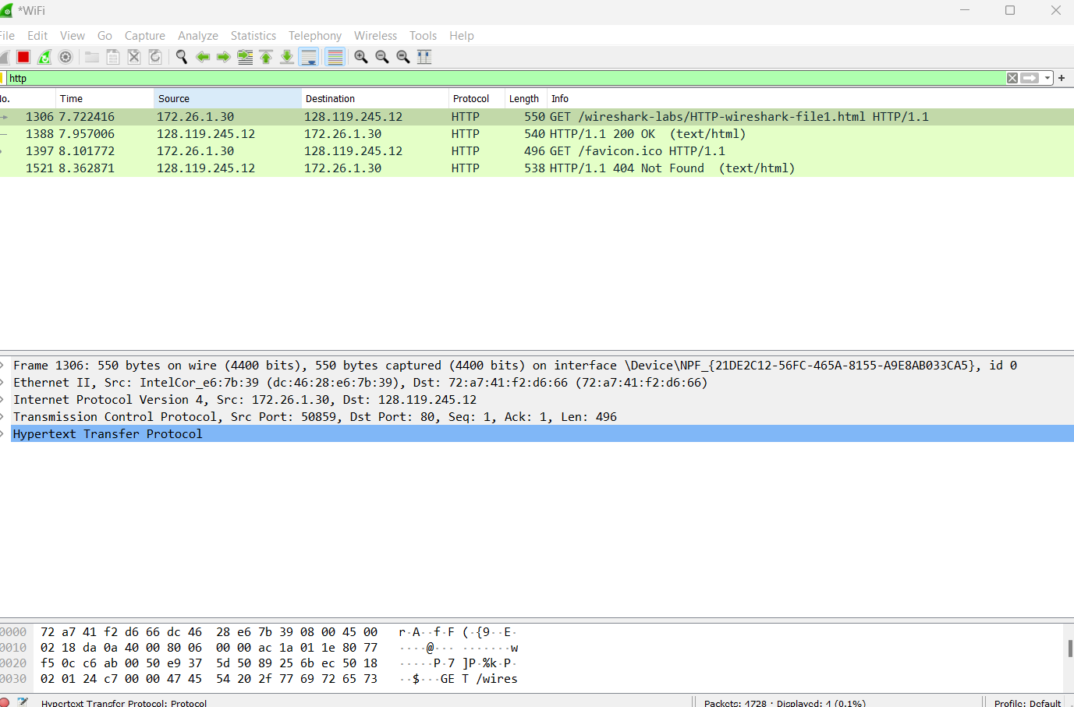

Both are version 1.1

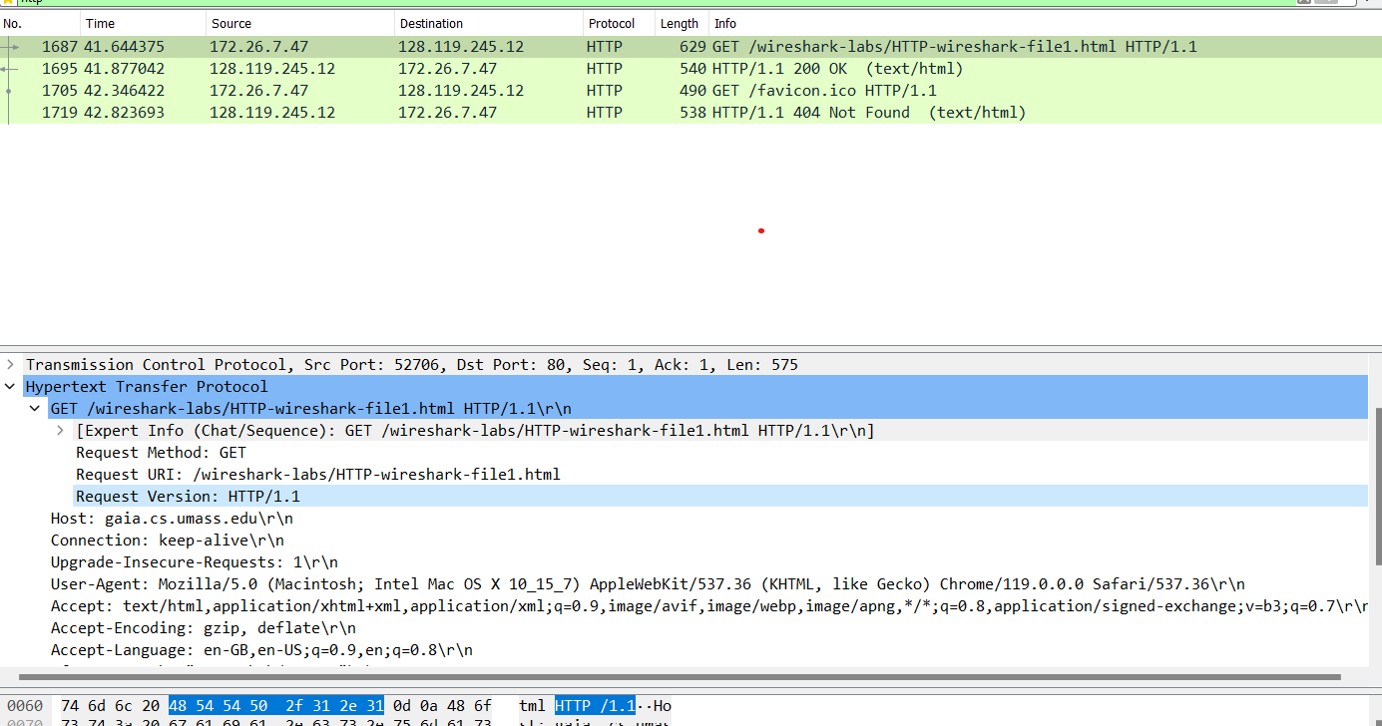

Q2. What version of HTTP is the server running?

Both of are version 1.1

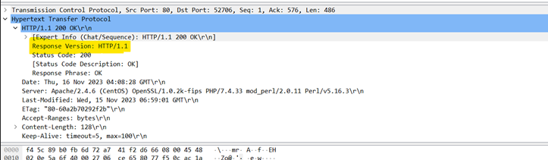

Q3: What languages (if any) does your browser indicate that it can accept to the server?
en-GB and en-US languages information is listed in the item “Accept-Language” in the http get message

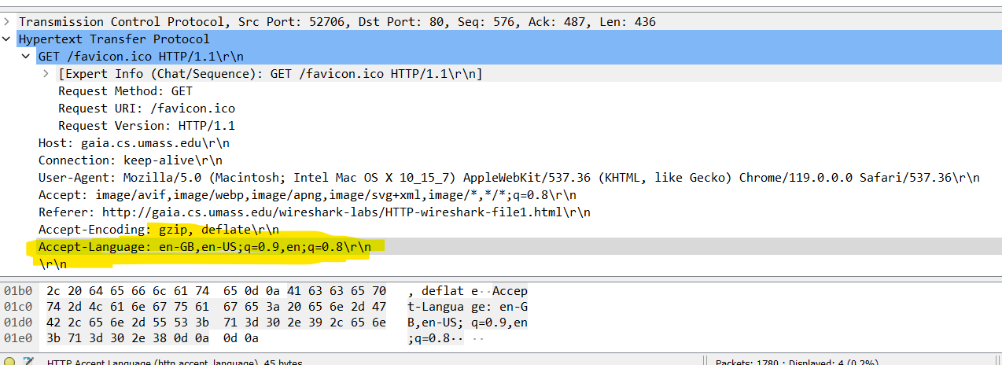

4. What is the IP address of your computer? What is the IP address of the gaia.cs.umass.edu server?

Computer = 172.26.7.47
gaia.cs.umass.edu = 128.119.245.12
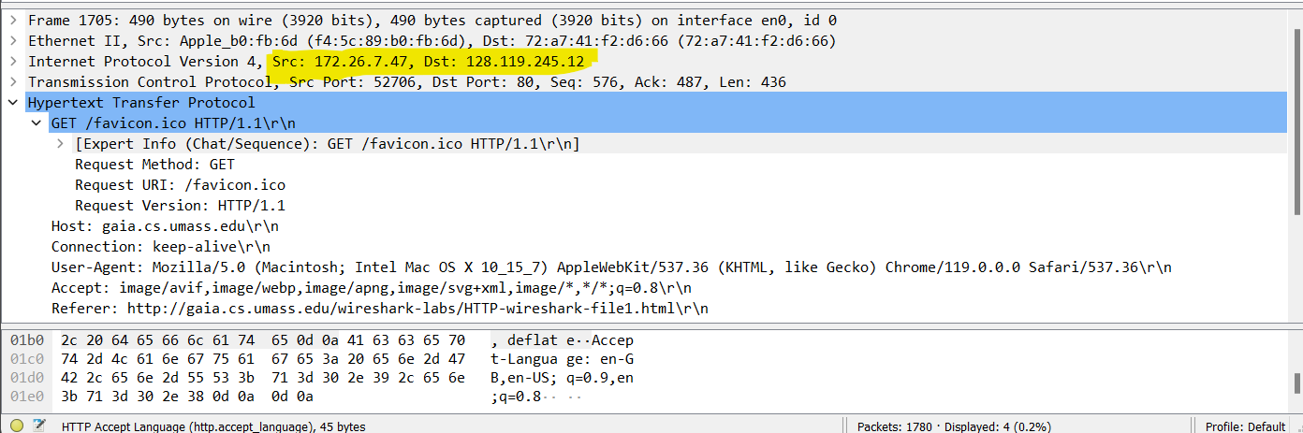

Q5: What is the status code returned from the server to your browser?

status code: 200-status code information is listed in HTTP ok message

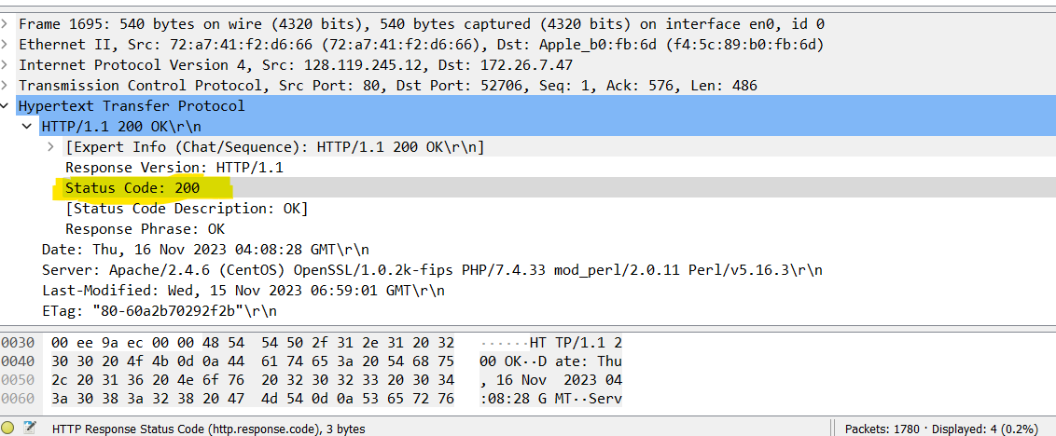

6. When was the HTML file that you are retrieving last modified at the server?

Wednesday, 15 NOV 2023
last modified information is listed in the item ‘Last-Modified’ in the http OK message

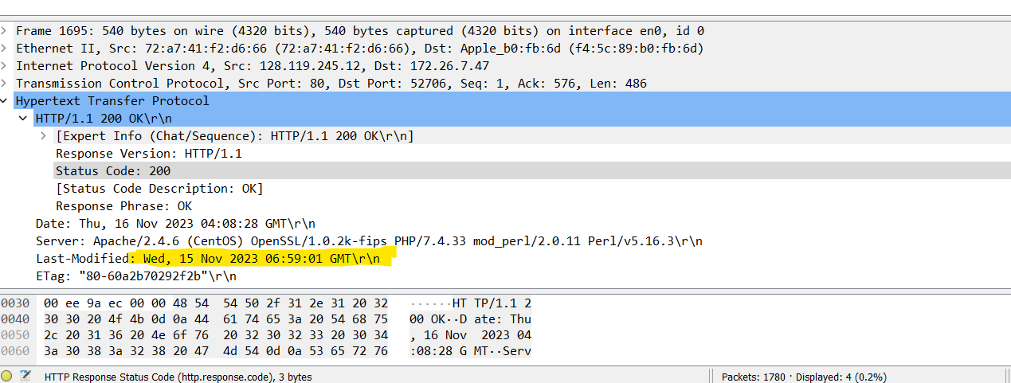

7. How many bytes of content are being returned to your browser?

Content length: 128

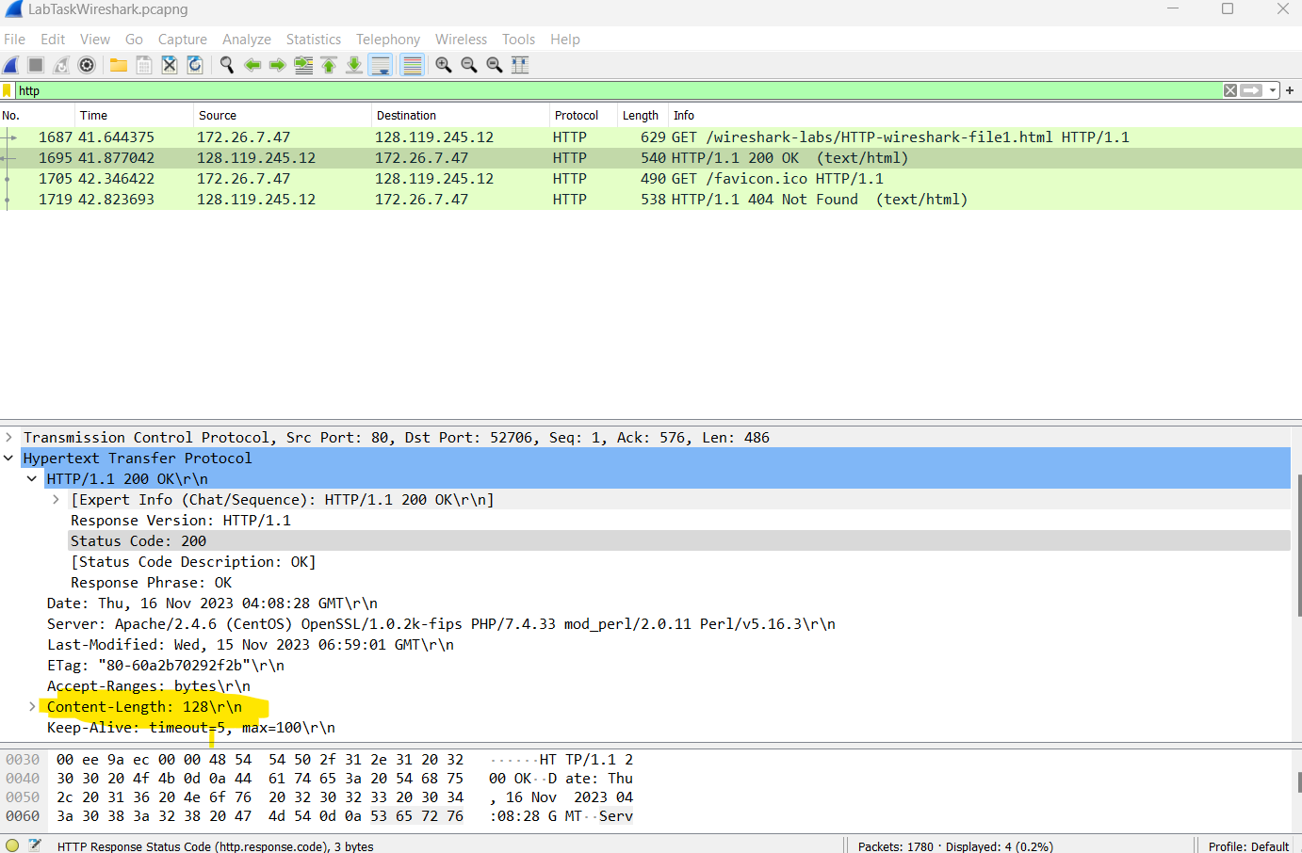

TASK 2:
Q1. Inspect the contents of the first HTTP GET request from your browser to the server. Do you see an “IF-MODIFIED-SINCE” line in the HTTP GET?

We got a response that said ‘HTTP/1.1 304 Not Found’.
Status code: 304 Response phrase: Not Modified.

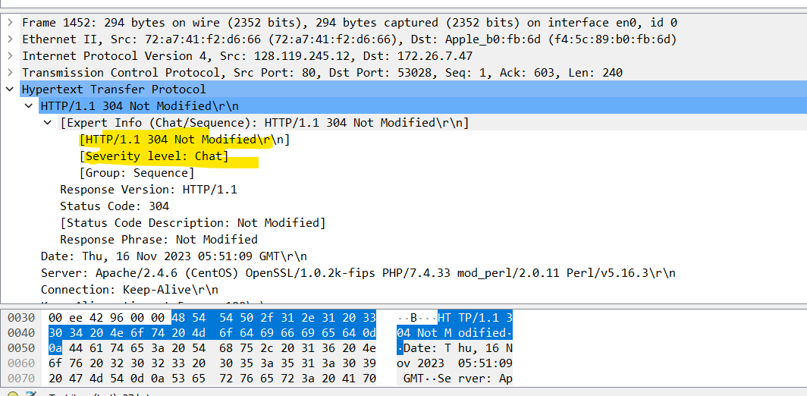

Q2- Inspect the contents of the server response. Did the server explicitly return the contents of the file? How can you tell?

Ans: The screenshot of first HTTP get message:
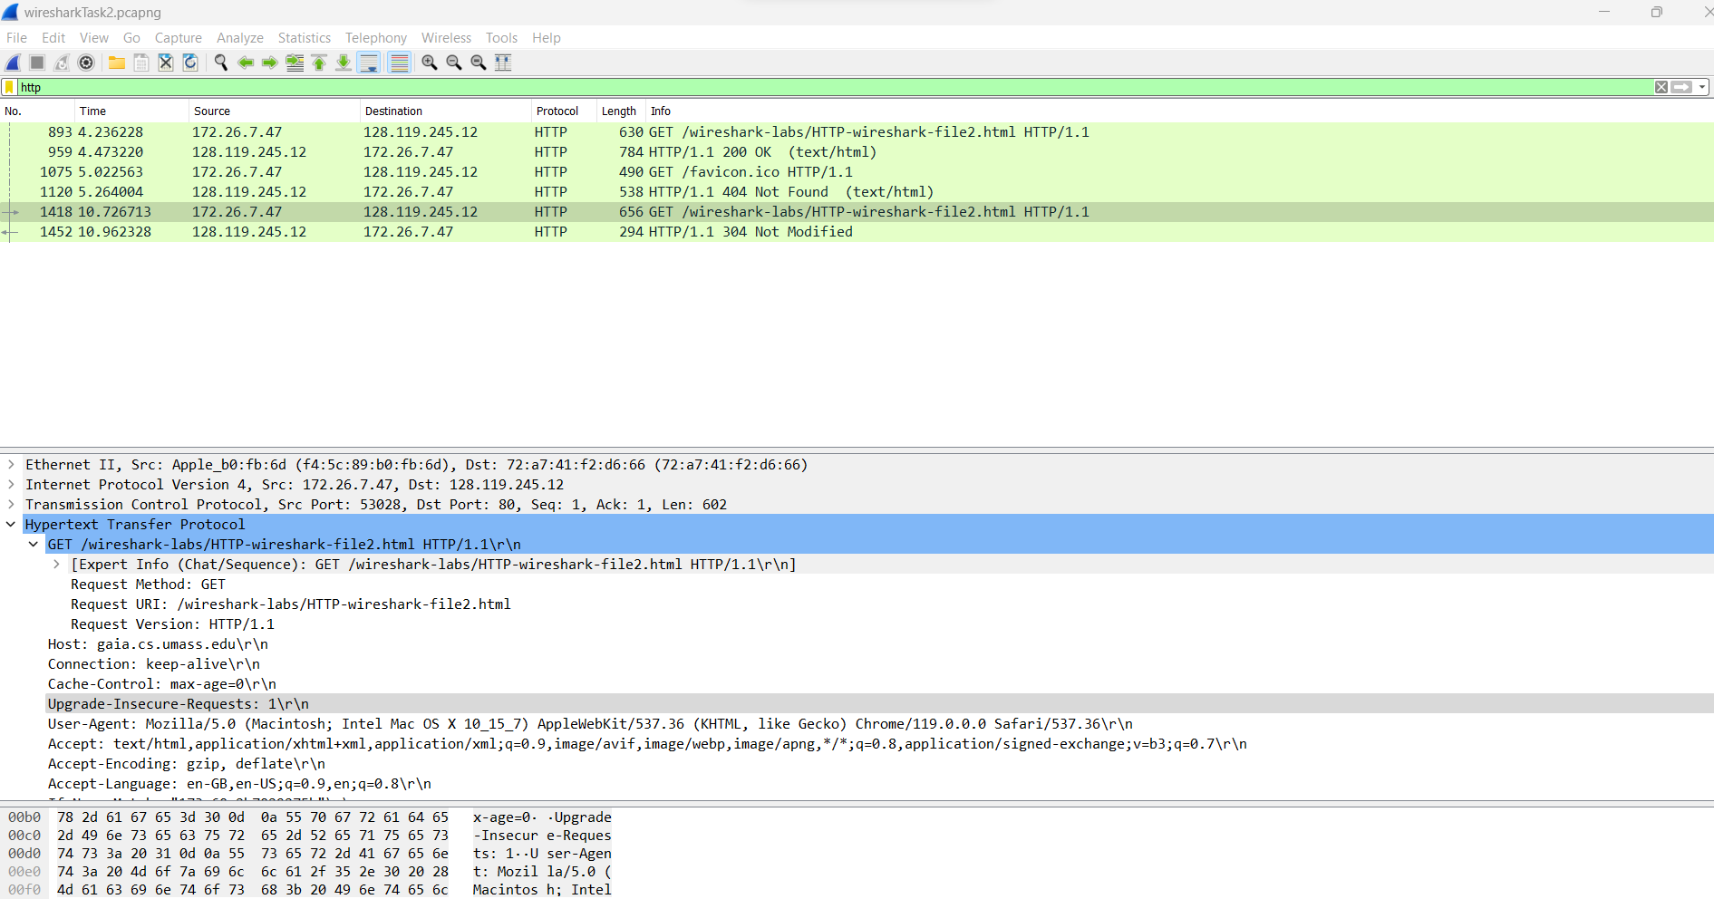

The screenshot of second HTTP GET message:
data is found sever;

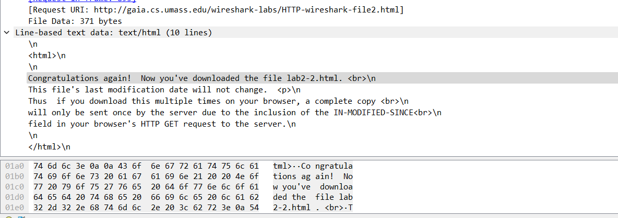

Q3: Now inspect the contents of the second HTTP GET request from your browser to the server. Do you see an “IF-MODIFIED-SINCE:” line in the HTTP GET ? If so, what information follows the “IF-MODIFIED-SINCE:” header?

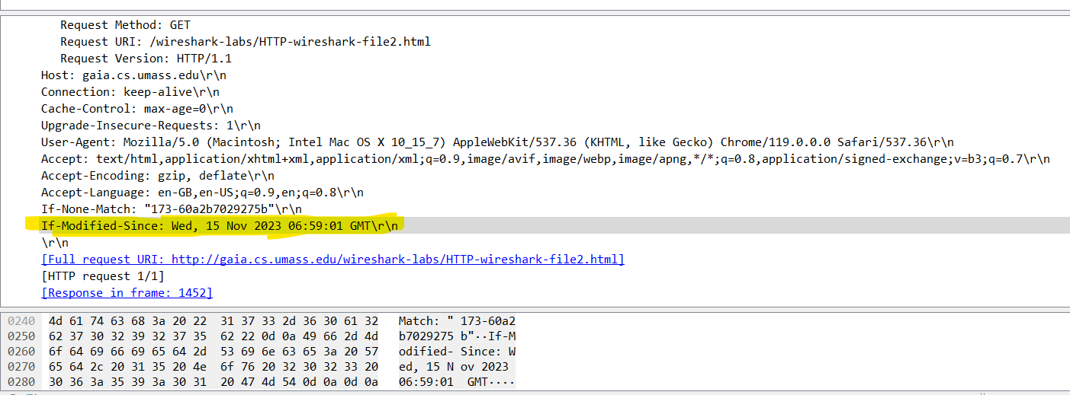

IF-MODIFIED-SINCE

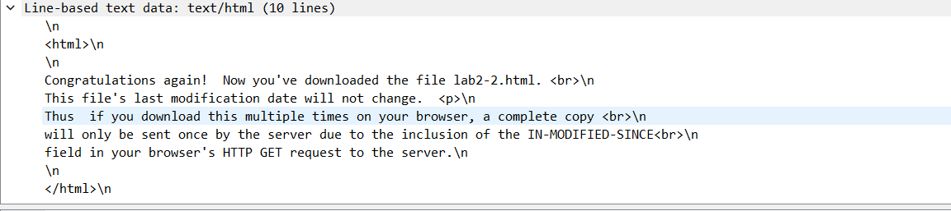

Q4: What is the HTTP status code and phrase returned from the server in response to this second HTTP GET? Did the server explicitly return the contents of the file? Explain.

